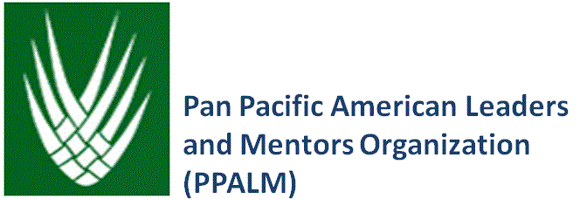
PPALM AND AAGEN LUNCHEON
LESSONS IN COURAGE AND CITIZENSHIP:
THE JAPANESE AMERICAN EXPERIENCE DURING WWII
March 30, 2013
11:30 AM to 2:00 PM
Fort Myer Officers Club, Arlington, VA

Hear about loyalty and perseverance from three Japanese Americans who lived through a time when the US government took away the constitutional rights of citizens because of their ethnicity – unprecedented and not to be repeated. Learn about the legacy of this experience.
PROGRAM
11:30 AM Lunch
12:00 Noon Welcome and Opening Remarks
Huong Pham and Sumiye Okubo, AAGEN

Noriko Sanefuji, Moderator
Panelists
Mary Murakami
Grant Ichikawa
Terry Shima
Q&A

2:00 PM Closing Remarks and Awards
MG Antonio Taguba, PPALM

TO REGISTER, GO TO http://www.aagen.org, Current Events (top right corner of home page).
PLEASE REGISTER EARLY. SPACE IS LIMITED.
Directions to Fort Myer: http://www.jbmhhmwr.com/index/Maps_and_Directions.html.
Please enter through the Main Gate from Washington Boulevard, and allow extra time to enter Fort Myer. Have a valid government issued ID or a valid driver’s license, a copy of the flyer, and observe the 15-mile speed limit (you may get ticketed).
The Officers Club is on Jackson Avenue. Parking areas are close by.
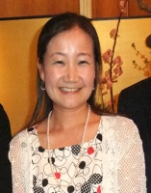
Noriko Sanefuji, Curatorial Assistant, Division of Work and Industry, National Museum of American History, holds a joint position at the Smithsonian Asian Pacific American Center (APAC). Her areas of focus are Japanese American history and culture, and Asian Pacific Americans in the workplace and in business. Over the past seven years at the Smithsonian, she has worked on the preservation of APA history and culture, organizing relevant public programs and the collection of artifacts. She has co-curated exhibits in the museum, including Sweet and Sour: The Americanization of the Chinese Restaurant (2010), Creating Hawai`i (2009) and Barriers to Bridges: Asian American Immigration (2008).

PANEL MEMBERS

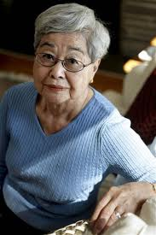
Mary Tamaki Murakami, citizen/lecturer. Since retiring in 2004, Mary Murakami has been speaking about the history of her family’s incarceration and that of 120,000 Japanese Americans during World War II. Her goal is to tell the history of the incarceration of Japanese Americans as a lesson in constitutional rights that must be understood and not forgotten. She has been invited as an individual speaker and on panels with members of the Japanese American Veterans Association (JAVA), in numerous forums, including public schools in Montgomery and Frederick Counties in Maryland, Arlington and Alexandria in Virginia, government agencies, churches, private schools and universities.

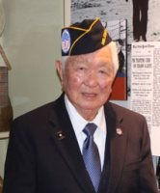
Grant Ichikawa, MIS veteran. Until June 2012, Grant Ichikawa produced the JAVA APAVET Roundtable newsletter, sending weekly news of all APA veterans across the United States and overseas. At the outbreak of World War II, he enrolled in the US Army Military Intelligence Service (MIS) Language School, and was assigned to the Allied Translations and Interpretation Service (ATIS) to participate in the Philippine liberation. Following Japan’s surrender, he talked 250 armed Japanese soldiers to surrender their weapons. He was one of 3,000 Japanese Americans who served in the Asia Pacific War in every combat unit as front line interrogators and translators, in the rear echelon as translators, and in Special Forces as communications interceptors behind enemy lines. He received the Congressional Gold Medal on behalf of the MIS unit in 2011.

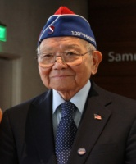
Terry Shima, 442 RCT Veteran. Terry Shima is currently the Chair of the Outreach and Education Committee and formerly the Executive Director of the Japanese American Veterans Association (JAVA). During World War II, he served as a replacement for the 442nd Regimental Combat Team, a segregated Japanese American infantry unit. He was later assigned to the 442nd Public Relations Office in Italy, until he and his unit returned to the US to handle public relations in New York City, Washington, DC, and Honolulu. He received the W. Coleman Nevils Gold Medal for the highest achievement in the field of US Foreign Relations. In addition, he and his unit were awarded the Congressional Gold Medal in 2011. On February 15, 2013 he received the Presidential Citizens Medal at the White House from President Obama.

