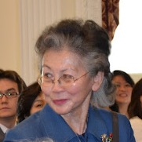
“I was very proud …”
Quote from the Honorable Ruby Moy, Member of AAGEN Board of Directors
"Yesterday's recognition of the President's Executive Order 'Increasing Participation of Asian Americans and Pacific Islanders in Federal Programs' hosted by the White House Initiative Asian Americans and Pacific Islanders (WHIAAPI) and AAGEN leveled the competition for all minorities to move upward. As a member of the AAGEN Board, I was very proud to see that the work that AAGEN Chair Tommy Hwang and his team made this happen and held a competition to select 20 candidates already on government payrolls to receive mentorship training by AAGEN to be on track for these SES positions."
Ruby G. Moy was appointed by President Clinton as Director of the U.S. Commission on Civil Rights. She is now President and CEO of the Asian American & Pacific Islander Association of Colleges and Universities (APIACU).

